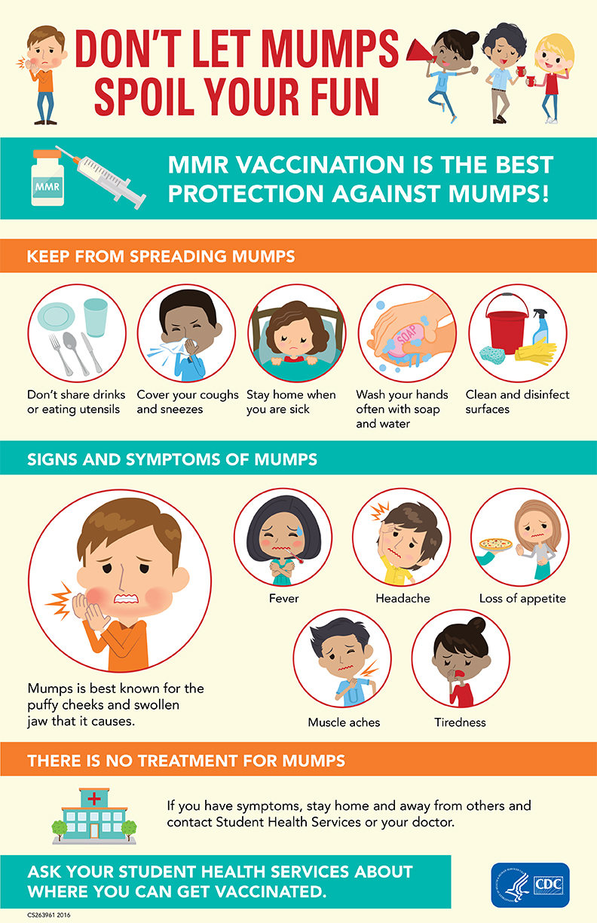

**Le Moyne College Wellness Center for Health & Counseling**

**Contact Health Services Today if you have symptoms.**

***315.445.4440***